**An Approach for Crop Prediction in Agriculture: Integrating Genetic Algorithms and Machine Learning**

**ABSTRACT:**

The agricultural sector in many South Asian countries, including Bangladesh and India, plays a pivotal role in the economy, with a significant portion of the population relying on it for their livelihood. However, farmers face challenges like unpredictable weather, soil variability, and natural disasters such as floods and erosion, leading to crop losses and financial difficulties. This often results in a decline in interest in agriculture despite government support. Our study focuses on predicting the classification of various crops, such as rice, jute, and maize, using a combination of soil and weather features. The predictive model leverages soil parameters like Nitrogen, Phosphorus, Potassium, and pH levels, alongside weather variables such as Temperature, Humidity, and Rainfall. We propose a hybrid approach that integrates machine learning with genetic algorithms, where a Random Forest Classifier is used for crop classification across 22 different crop types. The Genetic Algorithm is utilized to optimize hyperparameters, enhancing model performance and robustness. Additionally, we applied Explainable AI (XAI) techniques, including Local Interpretable Model-agnostic Explanations (LIME) and SHapley Additive exPlanations (SHAP), to interpret and validate the model’s predictions. By improving feature selection and model parameters, our approach addresses limitations associated with existing models, providing more reliable and accurate predictions. This system has the potential to reduce crop losses, improve agricultural productivity, and contribute to the sustainability and prosperity of the agricultural sector.

**TABLE OF CONTENTS**

|  |  |  |
| --- | --- | --- |
| **CHAPTER NO.** | **TITLE** | **PAGE NO.** |
|  | **ABSTRACT**  **LIST OF FIGURES**  **LIST OF SYMBOLS** | i  v  vii |
| 1. | **CHAPTER 1 : INTRODUCTION**   * 1. GENERAL   2. SCOPE OF THE PROJECT   3. OBJECTIVE   1.4 EXISTING SYSTEM  1.4.1 EXISTINGSYSTEM DISADVANTAGES  1.5 LITERATURE SURVEY  1.6 PROPOSED SYSTEM  1.6.1 PROPOSED SYSTEM ADVANTAGES |  |
| 2. | **CHAPTER 2 :PROJECT DESCRIPTION**  2.1 GENERAL  2.2 METHODOLOGIES  2.2.1 MODULES NAME  2.2.2 MODULES EXPLANATION  2.3 TECHNIQUE OR ALGORITHM |  |
| 3. | **CHAPTER 3 : REQUIREMENTS**  3.1 General  3.2 Hardware REQUIREMENTS  3.3 Software REQUIREMENTS |  |
| 4. | **CHAPTER 4 :SYSTEM DESIGN**  **4.1 general**  **4.2 uml diagrams**  4.2.1 USE CASE DIAGRAM  4.2.2 CLASS DIAGRAM  4.2.3 OBJECT DIAGRAM  4.2.4 STATE DIAGRAM  4.2.5 activity diagram  4.2.6 SEQUENCE DIAGRAM  4.2.7 COLLABORATION DIAGRAM  4.2.8 COMPONENT DIAGRAM  4.2.9 DATA FLOW DIAGRAM  4.2.10 DEPLOYMENT DIAGRAM  4.2.11 SYSTEM ARCHITECTURE |  |
| 5. | **CHAPTER 5 : DEVELOPMENT TOOLS**  5.1 general  5.2 History of Python  5.3 Importance of Python  5.4 Features of Python  5.5 Libraries used in python |  |
| 6. | **CHAPTER 6 :IMPLEMENTATION**  6.1 GENERAL  6.2 IMPLEMENTATION |  |

|  |  |  |
| --- | --- | --- |
| 7. | **CHAPTER 7 :SNAPSHOTS**  7.1 GENERAL  7.2 VARIOUS SNAPSHOTS |  |
| 8. | **CHAPTER 8 :SOFTWARE TESTING**  8.1 GENERAL  8.2 DEVELOPING METHODOLOGIES  8.3 TYPES OF TESTING |  |
| 9. | **CHAPTER 9 :**  **FUTURE ENHANCEMENT**  9.1 FUTURE ENHANCEMENTS |  |
| **10** | **CHAPTER 10 :**  10.1CONCLUSION  10.2 REFERENCES |  |

**LIST OF FIGURES**

|  |  |  |
| --- | --- | --- |
| **FIGURE NO** | **NAME OF THE FIGURE** | **PAGE NO.** |
|  |  |  |
| 4.1 | Use case Diagram |  |
| 4.2 | Class diagram |  |
| 4.3 | Object diagram |  |
| 4.4 | State Diagram |  |
| 4.5 | Activity Diagram |  |
| 4.6 | Sequence diagram |  |
| 4.7 | Collaboration diagram |  |
| 4.8 | Component Diagram |  |
| 4.9 | Data flow diagram |  |
| 4.10 | Deployment Diagram |  |
| 4.11 | Architecture Diagram |  |

**LIST OF SYSMBOLS**

|  |  |  |  |
| --- | --- | --- | --- |
| **S.NO** | **NOTATION**  **NAME** | **NOTATION** | **DESCRIPTION** |
| 1. | Class | *Class Name*  *-attribute*  *-attribute*  *+operation*  *+operation*  *+operation*  *+ public*  *-private*  *# protected* | Represents a collection of similar entities grouped together. |
| 2. | Association | name  Class B  Class A  Class A  Class B | Associations represents static relationships between classes. Roles represents the way the two classes see each other. |
| 3. | Actor | Class A  Class A  Class B  Class B | It aggregates several classes into a single classes. |
| 4. | Aggregation | Interaction between the system and external environment |

|  |  |  |  |
| --- | --- | --- | --- |
| 5. | Relation  (uses) | uses | Used for additional process communication. |
| 6. | Relation  (extends) | extends | Extends relationship is used when one use case is similar to another use case but does a bit more. |
| 7. | Communication |  | Communication between various use cases. |
| 8. | State | State | State of the processes. |
| 9. | Initial State |  | Initial state of the object |
| 10. | Final state |  | Final state of the object |
| 11. | Control flow |  | Represents various control flow between the states. |
| 12. | Decision box |  | Represents decision making process from a constraint |
| 13. | Use case |  | Interact ion between the system and external environment. |

|  |  |  |  |
| --- | --- | --- | --- |
| 14. | Component |  | Represents physical modules which are a collection of components. |
| 15. | Node |  | Represents physical modules which are a collection of components. |
| 16. | Data Process/State |  | A circle in DFD represents a state or process which has been triggered due to some event or action. |
| 17. | External entity |  | Represents external entities such as keyboard, sensors, etc. |
| 18. | Transition |  | Represents communication that occurs between processes. |
| 19. | Object Lifeline |  | Represents the vertical dimensions that the object communications. |
| 20. | Message | Message | Represents the message exchanged. |

**CHAPTER-1**

**INTRODUCTION**

1

1.Introduction :

Agriculture is the backbone of many South Asian countries, including Bangladesh and India, where a significant portion of the population depends on farming for their livelihoods. However, farmers in these regions face numerous challenges, such as unpredictable weather conditions, soil variability, and natural disasters like floods and erosion, which often result in crop losses and financial instability. Despite government support and subsidies, the agricultural sector continues to struggle, leading to a decline in interest among younger generations. In response to these challenges, accurate crop prediction has emerged as a critical area of research. By predicting the right crops to plant based on environmental conditions, farmers can make better decisions, mitigate losses, and improve productivity. This study aims to develop an advanced crop prediction model using machine learning techniques, integrating soil features like Nitrogen, Phosphorus, Potassium, and pH levels with weather variables such as Temperature, Humidity, and Rainfall. The proposed model leverages a **Random Forest Classifier** to classify 22 different crop types, enhancing the prediction process by utilizing **Genetic Algorithms (GA)** for hyperparameter optimization. Additionally, the model incorporates **Explainable AI (XAI)** techniques, such as **LIME** (Local Interpretable Model-agnostic Explanations) and **SHAP** (SHapley Additive exPlanations), to improve the transparency and interpretability of the predictions. These methods help in explaining the influence of individual features on the crop prediction, making the model more reliable and accessible for agricultural stakeholders. The integration of Genetic Algorithms with Random Forest enhances the performance of the model by optimizing its hyperparameters, ensuring more accurate and robust predictions. The combination of these advanced techniques promises to not only improve the accuracy of crop classification but also contribute to the sustainability and prosperity of the agricultural sector, offering a valuable tool to mitigate the impact of unpredictable environmental factors on crop yield.

**1.2** **SCOPE OF THE PROJECT**

The scope of this project is focused on developing an advanced crop prediction model to support agricultural decision-making in South Asian countries, where the sector plays a vital role in the economy and the livelihood of millions. The project aims to integrate machine learning techniques with environmental data—specifically, soil features (e.g., Nitrogen, Phosphorus, Potassium, pH levels) and weather conditions (e.g., Temperature, Humidity, Rainfall)—to accurately predict the most suitable crops to plant in specific regions and conditions. The proposed system uses a **Random Forest Classifier** for crop classification and optimizes its performance through **Genetic Algorithms** (GA), which fine-tune the model’s hyperparameters for improved accuracy and efficiency.

.

**1.3** **OBJECTIVE**

The objective of this project is to develop an advanced crop prediction system that can assist farmers in making informed decisions by accurately predicting the most suitable crops to plant based on environmental factors such as soil properties (e.g., Nitrogen, Phosphorus, Potassium, and pH levels) and weather conditions (e.g., Temperature, Humidity, and Rainfall). The model will employ a **Random Forest Classifier** for classifying 22 different crop types and will utilize **Genetic Algorithms** to optimize its hyperparameters, enhancing performance and accuracy. Additionally, the project aims to improve the model’s interpretability by integrating **Explainable AI (XAI)** techniques, such as **LIME** and **SHAP**, which will enable farmers to understand the factors influencing the model’s predictions. By providing transparent and reliable insights, the system will empower farmers to reduce crop losses, mitigate risks from unpredictable weather, and ultimately increase agricultural productivity. The model will be designed to be scalable, adaptable to changing agricultural conditions, and applicable across different geographical regions with varying climates and soil types. In doing so, the project seeks to contribute to sustainable farming practices, ensuring the long-term viability and profitability of the agricultural sector, thereby supporting the livelihoods of farmers and enhancing food security.

**1.4** **EXISTING SYSTEM:**

In the realm of agricultural research, numerous existing algorithms have been applied to address crop classification and prediction challenges, especially in regions like South Asia, where agriculture significantly impacts the economy and livelihoods. Traditional approaches such as Decision Tree Classifier, Support Vector Machine (SVM), Naive Bayes, and K-Nearest Neighbors (KNN) have been widely used to predict crop types based on various features like soil composition, weather conditions, and other environmental factors. These algorithms, while effective to some extent, often face limitations in terms of scalability, accuracy, and interpretability, particularly when dealing with large, complex datasets or diverse crop types. For instance, models like Decision Trees can easily overfit, while SVMs may struggle with multi-class classification and require intensive computational resources. Additionally, these traditional algorithms may not be flexible enough to adapt to varying soil and climatic conditions, which are crucial in predicting crop yields in diverse agricultural landscapes. The proposed algorithm leverages a hybrid methodology where the Genetic Algorithm is employed to fine-tune the hyperparameters of the Random Forest model, enhancing its performance in classifying 22 different types of crops such as rice, jute, and maize. By optimizing key parameters like the number of trees, depth, and feature selection, the integration of GAs ensures that the model is not only more accurate but also more adaptable to the variability in soil and weather conditions. Furthermore, to ensure the model’s predictions are transparent and interpretable, we incorporated Explainable AI (XAI) techniques, specifically Local Interpretable Model-agnostic Explanations (LIME) and SHapley Additive exPlanations (SHAP).

**1.4.1 EXISTINGSYSTEM DISADVANTAGES:**

* Lack of Interpretability
* Overfitting and Model Complexity
* Scalability and Computation Costs
* Feature Dependency and Sensitivity
* Difficulty in Handling Missing Data
* Limited Adaptability to Changing Conditions Problems.

**1.5** **LITERATURE SURVEY**

**Title:** Explainable Machine Learning for Crop Recommendation from Agriculture Sensor Data-a New Paradigm

**Author:** Samiran Das and Sujoy Chatterjee

**Year:** 2023

**Description:** The dwindling agricultural earnings and decrease in crop yield in recent years due to improper crop selection and fluctuation/ uncertainty in weather necessitate proper machine learning-based analysis. Machine learning methods can potentially alleviate the predicament caused by the lack of appropriate soil testing, consultation, and bias in manual suggestion. This work attempted to comprehend the agricultural sensor data and weather conditions and formulated the task in terms of supervised classification. The work obtained accurate suggestions in the presence of missing data, noise, etc. by using advanced machine learning methods. But recommendation alone is insufficient to convince farmers and other stakeholders to adopt this approach. Hence, this paper introduced explainable machine learning to completely comprehend the decision-making process. This work quantified the importance of features, explained individual prediction outcomes, and uncovered the rationale for decisions. The work employed state-of-the-art local interpretable model-agnostic, post-hoc explanation methods to provide in-depth insights. The insights obtained from the explanations can help the farmers develop a knowledge base and assist the farmers in choosing the appropriate sensors for the task. The human interpretable analysis enables the farmers to obtain satisfactory yields in these ever-changing and extreme weather conditions and environmental degradation.

**Title:** A Cloud Enabled Crop Recommendation Platform for Machine Learning-Driven Precision Farming.

**Author:** Navod Neranjan Thilakarathne, Muhammad Saifullah Abu Bakar, Pg Emerolylariffion Abas

**Year:** 2022.

**Description**: Modern agriculture incorporated a portfolio of technologies to meet the current demand for agricultural food production, in terms of both quality and quantity. In this technology-driven farming era, this portfolio of technologies has aided farmers to overcome many of the challenges associated with their farming activities by enabling precise and timely decision making on the basis of data that are observed and subsequently converged. In this regard, Artificial Intelligence (AI) holds a key place, whereby it can assist key stakeholders in making precise decisions regarding the conditions on their farms. Machine Learning (ML), which is a branch of AI, enables systems to learn and improve from their experience without explicitly being programmed, by imitating intelligent behavior in solving tasks in a manner that requires low computational power. For the time being, ML is involved in a variety of aspects of farming, assisting ranchers in making smarter decisions on the basis of the observed data. In this study, we provide an overview of AI-driven precision farming/agriculture with related work and then propose a novel cloud-based ML-powered crop recommendation platform to assist farmers in deciding which crops need to be harvested based on a variety of known parameters. Moreover, in this paper, we compare five predictive ML algorithms—K-Nearest Neighbors (KNN), Decision Tree (DT), Random Forest (RF), Extreme Gradient Boosting (XGBoost) and Support Vector Machine (SVM)—to identify the best-performing ML algorithm on which to build our recommendation platform as a cloud-based service with the intention of offering precision farming solutions that are free and open source, as will lead to the growth and adoption of precision farming solutions in the long run.

**Title:** Enhancing Crop Management: Ensemble Machine Learning for Real-Time Crop Recommendation System from Sensor Data.

**Author:** Nuzhat Prova, Sadia Hossain, Md Rezwane Sadik, Abdullah AI Maruf

**Year:** 2024.

**Description:** The agricultural industry is essential to the world’s food production, and it is critical to use cutting-edge technologies to increase crop productivity. We provide a revolutionary Crop Recommendation System (CRS) that utilizes cutting-edge technology to maximize crop output in response to the pressing need for improvement. Our study incorporates real-time monitoring of soil conditions, made possible by a custom hardware configuration that includes sensors for temperature, humidity, phosphorus, potassium, nitrogen, and pH measurements. First, we assembled a large dataset with 22 kinds of agricultural production components. Using many machine learning models, such as ensemble methods and baseline classifiers, we were able to classify crops with an astounding 99% accuracy rate. With the application of these insights, the CRS provides customized recommendations through an easy-to-use user interface for appropriate crops under particular climatic conditions. Our system’s innovative combination of hardware sensing capabilities and AI-driven decision-making promises to revolutionize crop management practices, offering actionable insights for agricultural stakeholders. Our system’s novel integration of AI-driven decision-making and hardware sensing capabilities promises to transform crop management techniques and provide agricultural stakeholders with useful insights.

**Title:**  Crop Prediction Model Using Machine Learning Algorithms

**Author:**  Ersin Elbasi, Chamseddine Zaki, Ahmet E.Topcu, Wiem Abdelbaki, Aymen I.Zreikat, Elda Cina, Ahmed Shdefat and Louai Saker.

**Year:** 2023

**Description**: — Machine learning applications are having a great impact on the global economy by transforming the data processing method and decision making. Agriculture is one of the fields where the impact is significant, considering the global crisis for food supply. This research investigates the potential benefits of integrating machine learning algorithms in modern agriculture. The main focus of these algorithms is to help optimize crop production and reduce waste through informed decisions regarding planting, watering, and harvesting crops. This paper includes a discussion on the current state of machine learning in agriculture, highlighting key challenges and opportunities, and presents experimental results that demonstrate the impact of changing labels on the accuracy of data analysis algorithms. The findings recommend that by analyzing wide-ranging data collected from farms, incorporating online IoT sensor data that were obtained in a real-time manner, farmers can make more informed verdicts about factors that affect crop growth. Eventually, integrating these technologies can transform modern agriculture by increasing crop yields while minimizing waste. Fifteen different algorithms have been considered to evaluate the most appropriate algorithms to use in agriculture, and a new feature combination scheme-enhanced algorithm is presented. The results show that we can achieve a classification accuracy of 99.59% using the Bayes Net algorithm and 99.46% using Naïve Bayes Classifier and Hoeffding Tree algorithms. These results will indicate an increase in production rates and reduce the effective cost for the farms, leading to more resilient infrastructure and sustainable environments. Moreover, the findings we obtained in this study can also help future farmers detect diseases early, increase crop production efficiency, and reduce prices when the world is experiencing food shortages.

**Title:** Crop Recommendation System Using Machine Learning Algorithm

**Author**: Prakalya Murali, Pradhusha Ayyasamy, Obuli.

**Year:** 2024**.**

**Description:** This study aims to develop an intelligent agricultural yield recommendation framework leveraging the capabilities of AI algorithms. The proposed framework takes yield efficiency and optimal growing seasons as crucial factors in generating appropriate crop recommendations. We have put forth four widely used models, namely Linear Regression (LR) and Multi-Layer Perceptron (MLP), which were trained and evaluated on a comprehensive dataset comprising historical agricultural data encompassing various features such as climatic factors, soil properties, and geographical variables. Furthermore, the data was segmented based on seasonal patterns to provide crop suggestions tailored to specific time periods. The performance of these models was assessed using standard metrics, and an ensemble approach was considered to enhance the system's robustness. Ultimately, the developed framework offers farmers and agricultural professionals a valuable tool for making informed decisions, optimizing crop selection, and enhancing overall agricultural productivity.

**1.6** **PROPOSED SYSTEM**

The proposed system in this study aims to address the limitations of traditional crop prediction models by introducing a novel hybrid approach that combines machine learning with genetic optimization techniques, specifically focusing on improving the accuracy and robustness of crop classification. Our system utilizes a **Random Forest Classifier**, a widely recognized ensemble learning method known for its high performance and ability to handle large datasets with multiple features, to classify a diverse range of crops, including rice, jute, maize, and others. However, to enhance the efficiency and predictive capability of this model, we integrate a **Genetic Algorithm (GA)** to optimize its hyperparameters. The Genetic Algorithm, inspired by the principles of natural selection, iteratively searches for the best combination of parameters, such as the number of trees, maximum depth, and feature subsets, to ensure that the Random Forest model achieves optimal performance. This approach allows the model to adapt more effectively to varying soil and climatic conditions, which are crucial factors in agricultural crop prediction.

**1.6.1** **PROPOSED SYSTEM ADVANTAGES:**

* Improved Accuracy and Performance
* Enhanced Interpretability with Explainable AI (LIME & SHAP)
* Optimized Hyperparameters through Genetic Algorithms
* Adaptability to Changing Agricultural Conditions
* Reduced Overfitting with Ensemble Learning (Random Forest).

**CHAPTER 2**

**PROJECT DESCRIPTION**

**2.1 GENERAL:**

Agriculture plays a crucial role in the economies of South Asian countries like Bangladesh and India, where it is the primary livelihood for a large portion of the population. However, these farmers face numerous challenges, including unpredictable weather patterns, soil variability, and natural disasters such as floods and erosion, which can lead to significant crop losses and financial instability. Despite the availability of government subsidies, these issues have led to a decline in interest in the agricultural sector, particularly among younger generations. Accurate crop prediction has thus become essential in mitigating these challenges. By predicting suitable crops based on environmental factors, farmers can optimize their crop choices, reduce risks, and increase productivity. This study focuses on developing a robust crop prediction model that combines machine learning techniques, using environmental data such as Nitrogen, Phosphorus, Potassium, pH levels, Temperature, Humidity, and Rainfall to predict the most suitable crops to plant. The proposed model utilizes a Random Forest Classifier, an ensemble learning method known for its ability to handle large datasets and complex relationships, to classify 22 different crop types. To enhance the performance of this classifier, Genetic Algorithms (GA) are employed to optimize its hyperparameters, thus ensuring that the model provides more accurate and reliable predictions. Furthermore, Explainable AI techniques like LIME (Local Interpretable Model-agnostic Explanations) and SHAP (SHapley Additive Explanations) are integrated into the model to increase its transparency and interpretability. These methods allow users to understand the contribution of individual features, such as soil properties and weather conditions, in the prediction process, making the model more user-friendly for agricultural stakeholders. The integration of Genetic Algorithms with Random Forest not only improves the accuracy of the predictions but also enhances the model's robustness, offering a reliable tool for addressing the challenges faced by farmers. By leveraging advanced machine learning techniques, the model aims to contribute significantly to the sustainability and productivity of agriculture in South Asia, enabling farmers to make informed decisions and mitigate the impact of unpredictable environmental conditions on crop yields.

**2.2 METHODOLOGIES**

**2.2.1MODULES NAME:**

**Modules Name:**

* Collecting the Dataset
* Data Analysis
* Data Pre-Processing
* Model Application
* Model Training
* Model Evaluation
* Prediction
  + 1. **MODULES EXPLANATION:**

1. **Collecting The Dataset:**

The first step involves gathering a diverse dataset that includes environmental factors influencing crop growth. This dataset comprises soil features such as Nitrogen, Phosphorus, Potassium, and pH levels, along with weather-related data like Temperature, Humidity, and Rainfall. It is important to source the data from multiple reliable platforms such as agricultural sensors, meteorological stations, and government records to ensure the dataset's quality and diversity. A comprehensive dataset forms the foundation for building an accurate prediction model that can assist farmers in making informed decisions.

1. **Data Analysis:**

Data analysis begins once the dataset is collected, aiming to identify underlying patterns and correlations between soil conditions, weather variables, and crop yields. Statistical tools and data visualization techniques are used to explore the relationships between variables. This phase also helps in detecting any anomalies, missing data, or outliers that could affect the quality of the model. The insights from the analysis help in selecting the most relevant features and guide subsequent steps in preprocessing, ensuring that the dataset is primed for model training.

**3) Data Pre-Processing:**

Data preprocessing is a critical phase where the dataset is cleaned and transformed into a suitable format for machine learning. Missing values are handled through imputation or removal, and outliers are detected and adjusted. Categorical variables, such as crop types, are encoded, and numerical features are normalized or scaled to ensure the model learns efficiently. Feature engineering is performed to enhance the dataset, and dimensionality reduction methods like PCA may be applied. This step ensures the data is consistent and ready for use in the model training process.

**4)** **Model Application:**

In the model application phase, the proposed algorithm is implemented. The Random Forest Classifier is used to classify various crop types based on the environmental data. To enhance its accuracy, Genetic Algorithms (GA) are applied to optimize the hyperparameters of the Random Forest model, such as the number of trees and tree depth. This optimization improves the model's performance by fine-tuning its internal parameters. Additionally, Explainable AI (XAI) methods, including LIME and SHAP, are integrated to ensure transparency, allowing users to understand how features like soil and weather conditions impact the predictions.

1. **Model Training:**

Model training involves feeding the cleaned and preprocessed dataset into the Random Forest model, which has been optimized using Genetic Algorithms. During this process, the model learns to identify patterns and relationships between the input features and the crop types. The training data is divided into subsets, allowing the model to iteratively adjust its parameters to minimize prediction error. Cross-validation techniques are also applied to ensure that the model generalizes well to unseen data, avoiding overfitting and ensuring robust performance on real-world data.

1. **Model Evaluation:**

After training, the model is evaluated using several performance metrics, such as accuracy, precision, recall, and F1-score. These metrics help assess the model's ability to make correct predictions and classify crop types effectively. A confusion matrix is used to visualize how well the model performs across different classes. Additionally, the model is tested using a separate validation dataset to ensure that it performs well on data it hasn't encountered during training. This evaluation phase is crucial for fine-tuning the model and ensuring its reliability in real-world scenarios.

1. **Prediction:**

Once the model is trained and evaluated, it is ready for making predictions. Given new environmental data, such as soil conditions and weather variables, the model predicts the most suitable crops to grow. These predictions are backed by explainability features such as LIME and SHAP, which show how different features influence the output. The ability to explain the predictions enhances trust in the model, providing farmers with actionable insights. This makes the model a valuable tool for farmers to improve their crop selection, reduce risks, and increase productivity.

**2.3 TECHNIQUE USED OR ALGORITHM USED**

**2.3.1** **EXISTING TECHNIQUE:**

In existing crop prediction systems, a variety of machine learning algorithms are commonly used for classifying crops based on features such as soil properties. These algorithms include the Random Forest Classifier, Decision Tree Classifier, Support Vector Machine (SVM), K-Nearest Neighbors (KNN), and Naive Bayes. Random Forest is an ensemble learning method that aggregates multiple decision trees to improve accuracy and reduce overfitting. Decision Trees make predictions by splitting the data into subsets based on feature values, though they are prone to overfitting. SVM is effective in high-dimensional spaces and works well with complex datasets but can be computationally expensive. KNN classifies data based on the majority class of neighboring data points, but its performance can degrade with large datasets. Naive Bayes applies probabilistic reasoning to classify data, assuming feature independence, though it may not perform well when features are correlated.

**2.3.2 PROPOSED TECHNIQUE USED OR ALGORITHM USED:**

The proposed system introduces a novel approach by integrating a Random Forest Classifier with a Genetic Algorithm (GA) to enhance the accuracy and efficiency of crop classification. The Random Forest Classifier, a robust ensemble learning method, is known for its ability to handle large datasets and complex feature interactions. It operates by constructing multiple decision trees during training and outputs the mode of the classes for classification tasks, thereby reducing overfitting and improving prediction accuracy. However, the performance of Random Forest heavily depends on its hyperparameters, such as the number of trees, maximum depth, minimum samples split, and feature selection, which require careful tuning to achieve optimal results.

The integration of Random Forest Classifier with Genetic Algorithm offers a powerful solution for crop classification by optimizing model parameters for higher accuracy and providing explainable insights into feature importance. This system not only improves predictive performance but also contributes to sustainable agricultural practices by supporting data-driven decision-making in crop management.

.

**CHAPTER 3**

**REQUIREMENTS ENGINEERING**

**3.1 GENERAL**

We can see from the results that on each database, the error rates are very low due to the discriminatory power of features and the regression capabilities of classifiers. Comparing the highest accuracies (corresponding to the lowest error rates) to those of previous works, our results are very competitive.

**3.2** **HARDWARE REQUIREMENTS**

The hardware requirements may serve as the basis for a contract for the implementation of the system and should therefore be a complete and consistent specification of the whole system. They are used by software engineers as the starting point for the system design. It should what the system do and not how it should be implemented.

* PROCESSOR : DUAL CORE 2 DUOS.
* RAM : 4GB DD RAM
* HARD DISK : 500 GB

**3.3** **SOFTWARE REQUIREMENTS**

The software requirements document is the specification of the system. It should include both a definition and a specification of requirements. It is a set of what the system should do rather than how it should do it. The software requirements provide a basis for creating the software requirements specification. It is useful in estimating cost, planning team activities, performing tasks and tracking the teams and tracking the team’s progress throughout the development activity.

* Operating System : Windows 10
* Platform : Spyder3
* Programming Language : Python
* Front End : Spyder3

**3.4** **FUNCTIONAL REQUIREMENTS**

A functional requirement defines a function of a software-system or its component. A function is described as a set of inputs, the behavior, Firstly, the system is the first that achieves the standard notion of semantic security for data confidentiality in attribute-based deduplication systems by resorting to the hybrid cloud architecture.

**3.5 NON-FUNCTIONAL REQUIREMENTS**

**The major non-functional Requirements of the system are as follows**

**Usability**

The system is designed with completely automated process hence there is no or less user intervention.

**Reliability**

The system is more reliable because of the qualities that are inherited from the chosen platform python. The code built by using python is more reliable.

**Performance**

This system is developing in the high level languages and using the advanced back-end technologies it will give response to the end user on client system with in very less time.

**Supportability**

The system is designed to be the cross platform supportable. The system is supported on a wide range of hardware and any software platform, which is built into the system.

**Implementation**

The system is implemented in web environment using Jupyter notebook software. The server is used as the intellignce server and windows 10 professional is used as the platform. Interface the user interface is based on Jupyter notebook provides server system.

**CHAPTER 4**

**DESIGN ENGINEERING**

**4.1 GENERAL**

Design Engineering deals with the various UML [Unified Modelling language] diagrams for the implementation of project. Design is a meaningful engineering representation of a thing that is to be built. Software design is a process through which the requirements are translated into representation of the software. Design is the place where quality is rendered in software engineering.

**4.2 UML DIAGRAMS**

**4.2.1 USE CASE DIAGRAM**

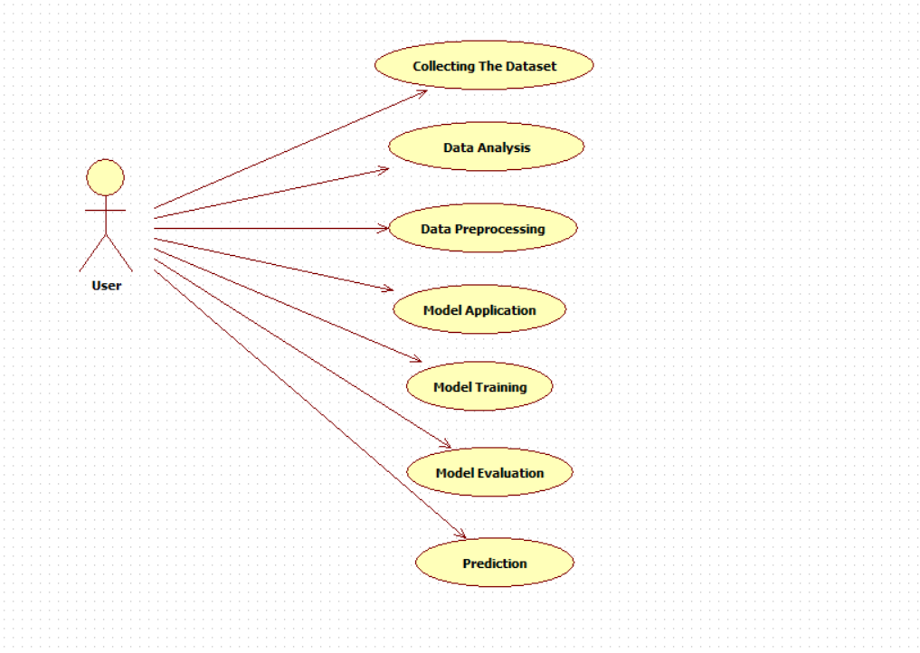

**EXPLANATION:**

The main purpose of a use case diagram is to show what system functions are performed for which actor. Roles of the actors in the system can be depicted. The above diagram consists of user as actor. Each will play a certain role to achieve the concept.

**4.2.2 CLASS DIAGRAM**

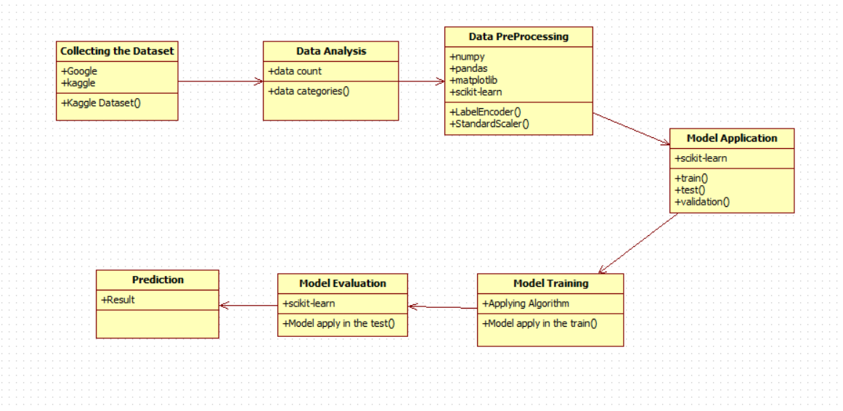

**EXPLANATION**

In this class diagram represents how the classes with attributes and methods are linked together to perform the verification with security. From the above diagram shown the various classes involved in our project.

**4.2.3 OBJECT DIAGRAM**

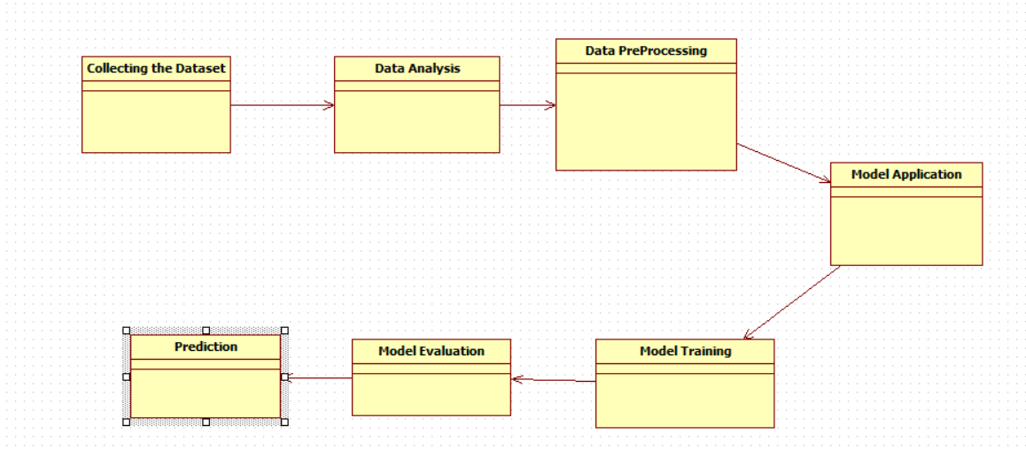

**EXPLANATION:**

In the above digram tells about the flow of objects between the classes. It is a diagram that shows a complete or partial view of the structure of a modeled system. In this object diagram represents how the classes with attributes and methods are linked together to perform the verification with security.

**4.2.4 STATE DIAGRAM**

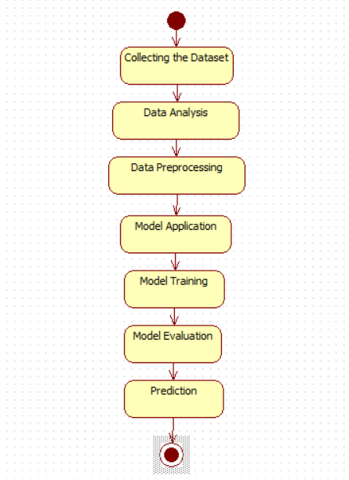

**EXPLANATION:**

State diagram are a loosely defined diagram to show workflows of stepwise activities and actions, with support for choice, iteration and concurrency. State diagrams require that the system described is composed of a finite number of states; sometimes, this is indeed the case, while at other times this is a reasonable abstraction. Many forms of state diagrams exist, which differ slightly and have different semantics.

**4.2.5 ACTIVITY DIAGRAM**

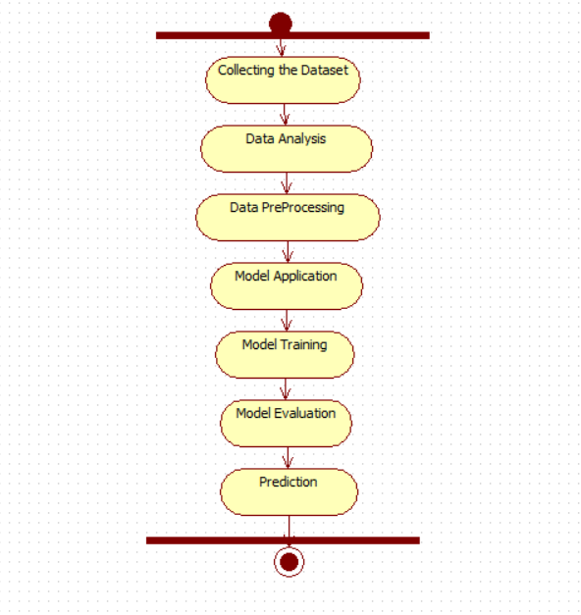

**EXPLANATION:**

Activity diagrams are graphical representations of workflows of stepwise activities and actions with support for choice, iteration and concurrency. In the Unified Modeling Language, activity diagrams can be used to describe the business and operational step-by-step workflows of components in a system. An activity diagram shows the overall flow of control.

**4.2.6 SEQUENCE DIAGRAM**

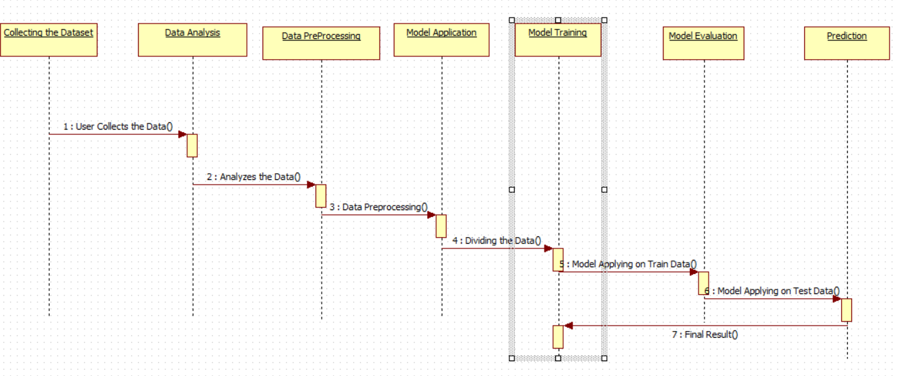

**EXPLANATION:**

A sequence diagram in Unified Modeling Language (UML) is a kind of interaction diagram that shows how processes operate with one another and in what order. It is a construct of a Message Sequence Chart. A sequence diagram shows object interactions arranged in time sequence. It depicts the objects and classes involved in the scenario and the sequence of messages exchanged between the objects needed to carry out the functionality of the scenario.

**4.2.7 COLLABORATION DIAGRAM**

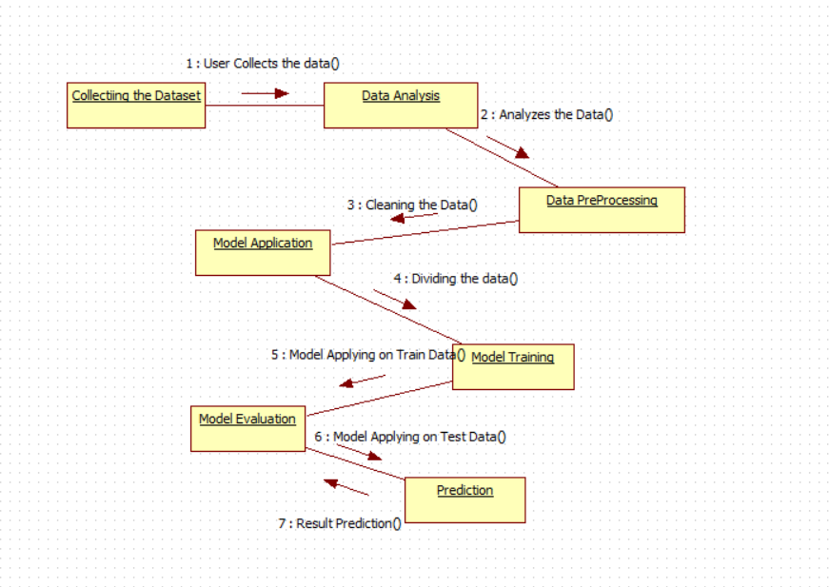

**EXPLANATION:**

A collaboration diagram, also called a communication diagram or interaction diagram, is an illustration of the relationships and interactions among software objects in the Unified Modeling Language (UML). The concept is more than a decade old although it has been refined as modeling paradigms have evolved.

**4.2.8 COMPONENT DIAGRAM**

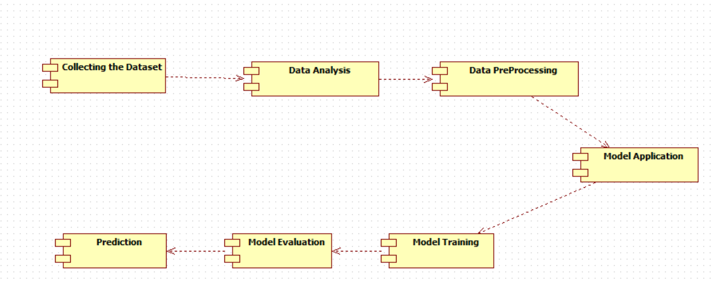

**EXPLANATION**

In the Unified Modeling Language, a component diagram depicts how components are wired together to form larger components and or software systems. They are used to illustrate the structure of arbitrarily complex systems. User gives main query and it converted into sub queries and sends through data dissemination to data aggregators. Results are to be showed to user by data aggregators. All boxes are components and arrow indicates dependencies.

**4.2.9 DATA FLOW DIAGRAM**

**Level 0**

Model Application

User

Data Collection

Data Preprocessing

**Level 1**

Prediction

Model Training

Hyper Parameter Tuning

Test Data

Fig 4.9: Data Flow Diagrams

**EXPLANATION:**

A data flow diagram (DFD) is a graphical representation of the "flow" of data through an information system, modeling its process aspects. Often they are a preliminary step used to create an overview of the system which can later be elaborated. DFDs can also be used for the visualization of data processing (structured design).

A DFD shows what kinds of data will be input to and output from the system, where the data will come from and go to, and where the data will be stored. It does not show information about the timing of processes, or information about whether processes will operate in sequence or in parallel.

**4.2.10 DEPLOYMENT DIAGRAM**

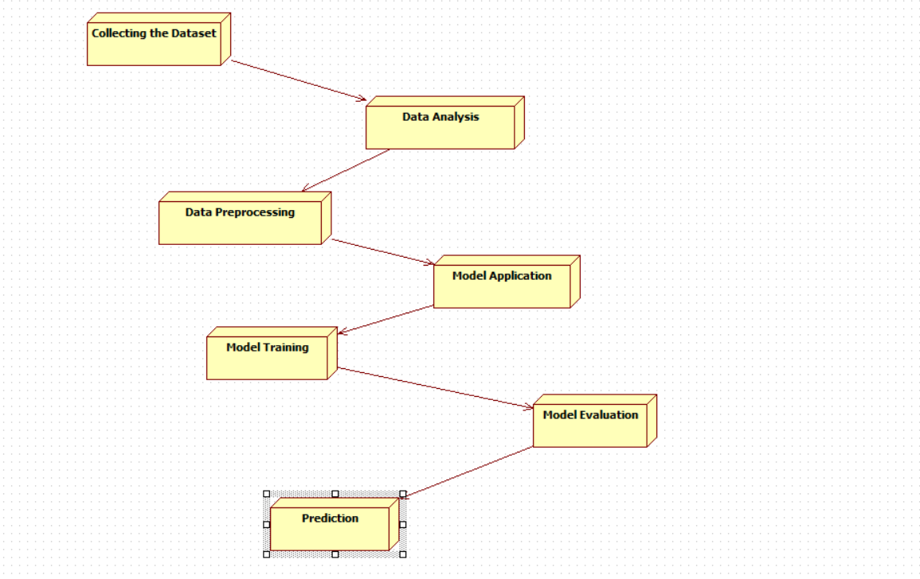

**EXPLANATION:**

Deployment Diagram is a type of diagram that specifies the physical hardware on which the software system will execute. It also determines how the software is deployed on the underlying hardware. It maps software pieces of a system to the device that are going to execute it.

**-**

**SYSTEM ARCHITECTURE:**

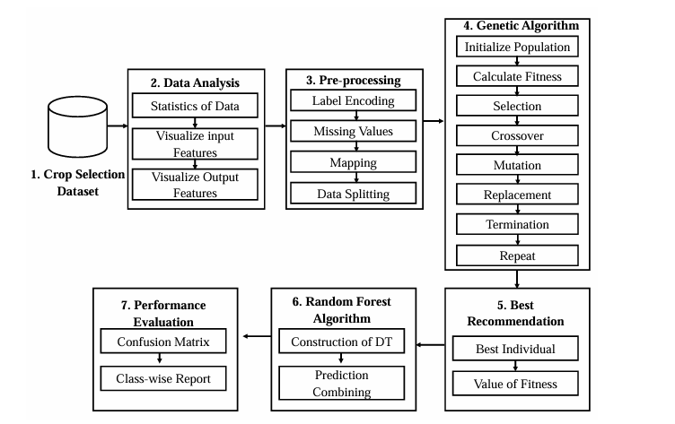

Fig 4.11: System Architecture

**CHAPTER 5**

**DEVELOPMENT TOOLS**

**5.1 Python**

Python is a high-level, interpreted, interactive and object-oriented scripting language. Python is designed to be highly readable. It uses English keywords frequently where as other languages use punctuation, and it has fewer syntactical constructions than other languages.

## 5.2 History of Python

Python was developed by Guido van Rossum in the late eighties and early nineties at the National Research Institute for Mathematics and Computer Science in the Netherlands.

Python is derived from many other languages, including ABC, Modula-3, C, C++, Algol-68, SmallTalk, and Unix shell and other scripting languages.

Python is copyrighted. Like Perl, Python source code is now available under the GNU General Public License (GPL).

Python is now maintained by a core development team at the institute, although Guido van Rossum still holds a vital role in directing its progress.

#### 5.3 Importance of Python

* **Python is Interpreted** − Python is processed at runtime by the interpreter. You do not need to compile your program before executing it. This is similar to PERL and PHP.
* **Python is Interactive** − You can actually sit at a Python prompt and interact with the interpreter directly to write your programs.
* **Python is Object-Oriented** − Python supports Object-Oriented style or technique of programming that encapsulates code within objects.
* **Python is a Beginner's Language** − Python is a great language for the beginner-level programmers and supports the development of a wide range of applications from simple text processing to WWW browsers to games.

#### 5.4 Features of Python

* **Easy-to-learn** − Python has few keywords, simple structure, and a clearly defined syntax. This allows the student to pick up the language quickly.
* **Easy-to-read** − Python code is more clearly defined and visible to the eyes.
* **Easy-to-maintain** − Python's source code is fairly easy-to-maintain.
* **A broad standard library** − Python's bulk of the library is very portable and cross-platform compatible on UNIX, Windows, and Macintosh.
* **Interactive Mode** − Python has support for an interactive mode which allows interactive testing and debugging of snippets of code.
* **Portable** − Python can run on a wide variety of hardware platforms and has the same interface on all platforms.
* **Extendable** − You can add low-level modules to the Python interpreter. These modules enable programmers to add to or customize their tools to be more efficient.
* **Databases** − Python provides interfaces to all major commercial databases.
* **GUI Programming** − Python supports GUI applications that can be created and ported to many system calls, libraries and windows systems, such as Windows MFC, Macintosh, and the X Window system of Unix.
* **Scalable** − Python provides a better structure and support for large programs than shell scripting.

Apart from the above-mentioned features, Python has a big list of good features, few are listed below −

* It supports functional and structured programming methods as well as OOP.
* It can be used as a scripting language or can be compiled to byte-code for building large applications.
* It provides very high-level dynamic data types and supports dynamic type checking.
* IT supports automatic garbage collection.
* It can be easily integrated with C, C++, COM, ActiveX, CORBA, and Java.

**5.5 Libraries used in python**

* numpy - mainly useful for its N-dimensional array objects.
* pandas - Python data analysis library, including structures such as dataframes.
* matplotlib - 2D plotting library producing publication quality figures.
* scikit-learn - the machine learning algorithms used for data analysis and data mining tasks.

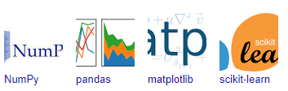

Figure : NumPy, Pandas, Matplotlib, Scikit-learn

**CHAPTER 6**

**IMPLEMENTATION**

**6.1 GENERAL**

**Coding:**

**CHAPTER 7**

**SNAPSHOTS**

**General:**

This project is implements like application using python and the Server process is maintained using the SOCKET & SERVERSOCKET and the Design part is played by Cascading Style Sheet.

**SNAPSHOTS**

**CHAPTER 8**

**SOFTWARE TESTING**

**8.1 GENERAL**

The purpose of testing is to discover errors. Testing is the process of trying to discover every conceivable fault or weakness in a work product. It provides a way to check the functionality of components, sub assemblies, assemblies and/or a finished product It is the process of exercising software with the intent of ensuring that the Software system meets its requirements and user expectations and does not fail in an unacceptable manner. There are various types of test. Each test type addresses a specific testing requirement.

**8.2 DEVELOPING METHODOLOGIES**

The test process is initiated by developing a comprehensive plan to test the general functionality and special features on a variety of platform combinations. Strict quality control procedures are used. The process verifies that the application meets the requirements specified in the system requirements document and is bug free. The following are the considerations used to develop the framework from developing the testing methodologies.

**8.3Types of Tests**

**8.3.1 Unit testing**

Unit testing involves the design of test cases that validate that the internal program logic is functioning properly, and that program input produce valid outputs. All decision branches and internal code flow should be validated. It is the testing of individual software units of the application .it is done after the completion of an individual unit before integration. This is a structural testing, that relies on knowledge of its construction and is invasive. Unit tests perform basic tests at component level and test a specific business process, application, and/or system configuration. Unit tests ensure that each unique path of a business process performs accurately to the documented specifications and contains clearly defined inputs and expected results.

**8.3.2 Functional test**

Functional tests provide systematic demonstrations that functions tested are available as specified by the business and technical requirements, system documentation, and user manuals.

Functional testing is centered on the following items:

Valid Input : identified classes of valid input must be accepted.

Invalid Input : identified classes of invalid input must be rejected.

Functions : identified functions must be exercised.

Output : identified classes of application outputs must be exercised.

Systems/Procedures: interfacing systems or procedures must be invoked.

**8.3.3 System Test**

System testing ensures that the entire integrated software system meets requirements. It tests a configuration to ensure known and predictable results. An example of system testing is the configuration oriented system integration test. System testing is based on process descriptions and flows, emphasizing pre-driven process links and integration points.

**8.3.4 Performance Test**

The Performance test ensures that the output be produced within the time limits,and the time taken by the system for compiling, giving response to the users and request being send to the system for to retrieve the results.

**8.3.5 Integration Testing**

Software integration testing is the incremental integration testing of two or more integrated software components on a single platform to produce failures caused by interface defects.

The task of the integration test is to check that components or software applications, e.g. components in a software system or – one step up – software applications at the company level – interact without error.

**8.3.6 Acceptance Testing**

User Acceptance Testing is a critical phase of any project and requires significant participation by the end user. It also ensures that the system meets the functional requirements.

**Acceptance testing for Data Synchronization:**

* The Acknowledgements will be received by the Sender Node after the Packets are received by the Destination Node
* The Route add operation is done only when there is a Route request in need
* The Status of Nodes information is done automatically in the Cache Updation process

**8.2.7 Build the test plan**

Any project can be divided into units that can be further performed for detailed processing. Then a testing strategy for each of this unit is carried out. Unit testing helps to identity the possible bugs in the individual component, so the component that has bugs can be identified and can be rectified from errors.

**CHAPTER 9**

**FUTURE ENHANCEMENT**

**9.1 FUTURE ENHANCEMENTS:**

Future enhancements to this project could focus on integrating real-time data collection through IoT-based sensors deployed in agricultural fields. This would allow for up-to-date environmental inputs such as soil moisture levels, temperature, and rainfall to continuously feed the model, improving prediction accuracy. Additionally, expanding the model to accommodate more advanced machine learning algorithms like deep learning or neural networks could further enhance its predictive power. Incorporating a wider variety of environmental factors, such as air quality or pest activity, could improve the model's adaptability to different crops and regions. Moreover, developing a user-friendly mobile application would allow farmers to access real-time predictions and actionable recommendations directly in the field, making the technology more accessible. Finally, enhancing the model's scalability for global application, including adjustments for different soil types, climates, and agricultural practices, could extend its impact, helping farmers worldwide make better decisions to increase productivity and reduce environmental risks.

**CHAPTER 10**

**CONCLUSIONAND REFERENCES**

**10.1** **CONCLUSION**

In conclusion, this project presents a robust solution for crop prediction by effectively combining machine learning techniques with Genetic Algorithms (GA) and Explainable AI methods like LIME and SHAP. The integration of the Random Forest Classifier with hyperparameter optimization via GA ensures improved prediction accuracy, enabling better crop classification under varying environmental conditions. The use of explainable methods adds transparency, allowing farmers to understand how soil and weather factors influence crop recommendations, thereby enhancing trust in the model. With the potential to reduce crop losses and enhance agricultural productivity, this system offers a sustainable approach to overcoming challenges faced by farmers, ultimately contributing to the long-term prosperity of the agricultural sector. By providing actionable insights and improving decision-making, the model empowers farmers to make informed choices, ensuring food security and resilience against unpredictable climatic conditions. Future developments, including the integration of real-time data and mobile solutions, could further increase the model's effectiveness, helping even more farmers worldwide to thrive despite environmental challenges.

**10.2 REFERENCES**

[1] “The world factbook.” https://www.cia.gov/the-world-factbook/countries/bangladesh/. Accessed: 2023-8-10.

[2] “Bureau of south and central asian affairs.” https://2009-2017.state.gov/r/pa/ei/bgn/3452.htm. Accessed: 2023-8-10.

[3] “India economic survey 2018.” https://www.financialexpress.com/budget/india-economic-survey-2018-for-farmers-agriculture-gdp-msp-1034266/. Accessed: 2023-8-10.

[4] M. H. Imam, N. Nahar, R. Bhowmik, S. B. S. Omit, T. Mahmud, M. S. Hossain, and K. Andersson, “A transfer learning-based framework: Mobilenet-svm for efficient tomato leaf disease classification,” in 2024 6th International Conference on Electrical Engineering and Information

&Communication Technology (ICEEICT), pp. 693–698, 2024.

[5] Y. Akkem, S. K. Biswas, and A. Varanasi, “Smart farming using artificial intelligence: A review,” Engineering Applications of Artificial Intelligence, vol. 120, p. 105899, 2023.

[6] T. Mahmud, K. Barua, A. Barua, N. Basnin, S. Das, M. S. Hossain, and K. Andersson, “Explainable ai for tomato leaf disease detection: Insights into model interpretability,” in 2023 26th International Conference on Computer and Information Technology (ICCIT), pp. 1–6, IEEE, 2023.

[7] T. Mahmud, M. Ptaszynski, and F. Masui, “Exhaustive study into machine learning and deep learning methods for multilingual cyberbullying detection in bangla and chittagonian texts,” Electronics, vol. 13, no. 9, p. 1677, 2024.

[8] A. S. Khan, F. T. Khan, T. Mahmud, S. K. Khan, N. Sharmen, M. S.Hossain, and K. Andersson, “Integrating bert embeddings with svm for prostate cancer prediction,” in 2024 6th International Conference on Electrical Engineering and Information & Communication Technology (ICEEICT), pp. 01–06, 2024.

[9] S.UmmeHabiba,F.Tasnim,M.S.HasanChowdhury,M.K.Islam,L.Nahar, T. Mahmud, M. S. Kaiser, M. S. Hossain, and K. Andersson, “Early prediction of chronic kidney disease using machine learning algorithms with feature selection techniques,” in International Conference on Applied Intelligence and Informatics, pp. 224–242, Springer, 2023.

[10] A. D. Bappy, T. Mahmud, M. S. Kaiser, M. Shahadat Hossain, and K. Andersson, “A bert-based chatbot to support cancer treatment follow up,” in International Conference on Applied Intelligence and Informatics,pp. 47–64, Springer, 2023.

[11] S. Das, T. Mahmud, D. Islam, M. Begum, A. Barua, M. Tarek Aziz, E. Nur Showan, L. Dey, E. Chakma, et al., “Deep transfer learning-based foot no-ball detection in live cricket match,” Computational Intelligence and Neuroscience, vol. 2023, 2023.

[12] T. Mahmud, M. Ptaszynski, J. Eronen, and F. Masui, “Cyberbullying detection for low-resource languages and dialects: Review of the state of the art,” Information Processing & Management, vol. 60, no. 5, p. 103454,2023.

[13] L. Bi and G. Hu, “A genetic algorithm-assisted deep learning approach forcrop yield prediction,” Soft Computing, vol. 25, pp. 10617–10628, 2021.

[14] V. Geetha, A. Punitha, M. Abarna, M. Akshaya, S. Illakiya, and A. Janani,“An effective crop prediction using random forest algorithm,” in 2020 International Conference on System, Computation, Automation and Networking (ICSCAN), pp. 1–5, IEEE, 2020.

[15] N. Jain, A. Kumar, S. Garud, V. Pradhan, and P. Kulkarni, “Crop selection method based on various environmental factors using machine learning,” International Research Journal of Engineering and Technology (IRJET),vol. 4, no. 02, pp. 551–558, 2017.

[16] S. Rani, A. K. Mishra, A. Kataria, S. Mallik, and H. Qin, “Machine learning-based optimal crop selection system in smart agriculture,” Scientific Reports, vol. 13, no. 1, p. 15997, 2023.

[17] S. Jain and D. Ramesh, “Machine learning convergence for weather based crop selection,” in 2020 IEEE International Students’ Conference on Electrical, Electronics and Computer Science (SCEECS), pp. 1–6, IEEE, 2020.

[18] M.A.Devi, D. Suresh, D. Jeyakumar, D. Swamydoss, and M. L. Florence, “Agriculture crop selection and yield prediction using machine learning algorithms,” in 2022 second international conference on artificial intelligence and smart energy (ICAIS), pp. 510–517, IEEE, 2022.

[19] M.S.Rao,A.Singh,N.S.Reddy,andD.U.Acharya,“Cropprediction using machine learning,” in Journal of Physics: Conference Series, vol. 2161, p. 012033, IOP Publishing, 2022.

[20] E. Elbasi, C. Zaki, A. E. Topcu, W. Abdelbaki, A. I. Zreikat, E. Cina,A. Shdefat, and L. Saker, “Crop prediction model using machine learning algorithms,” Applied Sciences, vol. 13, no. 16, p. 9288, 2023.

[21] S.Raja, B.Sawicka, Z. Stamenkovic, and G. Mariammal, “Cropprediction based on characteristics of the agricultural environment using various feature selection techniques and classifiers,” IEEE Access, vol. 10, pp. 2362523641, 2022.

[22] D. Modi, A. V. Sutagundar, V. Yalavigi, and A. Aravatagimath, “Crop recommendation using machine learning algorithm,” in 2021 5th International Conference on Information Systems and Computer Networks (ISCON), pp. 1–5, IEEE, 2021.

[23] P. Murali, P. Ayyasamy, O. Obuli, et al., “Crop recommendation system using machine learning algorithm,” International Research Journal on Advanced Engineering Hub (IRJAEH), vol. 2, no. 05, pp. 1237–1242,2024.

[24] N. A. Patil and S. Mane, “Crop recommendation in precision agriculture using machine learning techniques,” 2024.

[25] K. Nischitha, D. Vishwakarma, M. N. Ashwini, and M. Manjuraju, “Crop prediction using machine learning approaches,” International Journal of Engineering Research & Technology (IJERT), vol. 9, no. 08, pp. 23–26, 2020.

[26] H. Karthikeya, K. Sudarshan, and D. S. Shetty, “Prediction of agricultural crops using knn algorithm,” Int. J. Innov. Sci. Res. Technol, vol. 5, no. 5,pp. 1422–1424, 2020.

[27] H. Cao, Y. Gu, J. Fang, Y. Hu, W. Ding, H. He, and G. Chen, “Application of stacking ensemble learning model in quantitative analysis of biomaterial activity,” Microchemical Journal, vol. 183, p. 108075, 2022.

[28] “Indian council of agricultural research.” https://icar.org.in. Accessed: 2023-8-10.

[29] M. L. Waskom, “Seaborn: statistical data visualization,” Journal of Open Source Software, vol. 6, no. 60, p. 3021, 2021.

[30] R. Guedrez, O. Dugeon, S. Lahoud, and G. Texier, “Label encoding algorithm for mpls segment routing,” in 2016 IEEE 15th International Symposium on Network Computing and Applications (NCA), pp. 113117, IEEE, 2016.